Understanding binary addition Workbook
Name: Date

There are 1 0 types of people in the world.
Counting binary
The position of a binary bit shows its value.
1 = 1 1 0 = 2 1 0 0 = 4 1 0 0 0 = 8
In binary if we add 1 0 + 0 1 = 3 or in binary 1 1 one lot of two’s and one lot of ones .If we add 1 1 + 1 = 4 just as 3 + 1 = 4 in binary this is written as 1 0 0.
.

Those who understand binary and those who don’t.

Values of binary for a byte
256 | 128 | 64 | 32 | 16 | 8 | 4 | 2 | 1
If there are zeros in all the columns apart from 16, which has a 1 in, the binary number would be 16.

Binary addition sums
0+0 = 0, with no carry,
1+0 = 1, with no carry,
0+1 = 1, with no carry,
1+1 = 0, and you carry a 1.

Add in your own notes here

Reading binary numbers
When you see 10 in binary you should think of this as one zero not ten. The 1 means there is one lot of two and the zero means there are no ones. In the same way when you see 100 in binary you should say one zero zero not one hundred as this means one lot of four, no two’s and no ones.

This comic strip was generated at http://www.MakeBeliefsComix.com. Used by permission of author and site creator Bill Zimmerman. All other material used by permission of Ms K. Donkin.

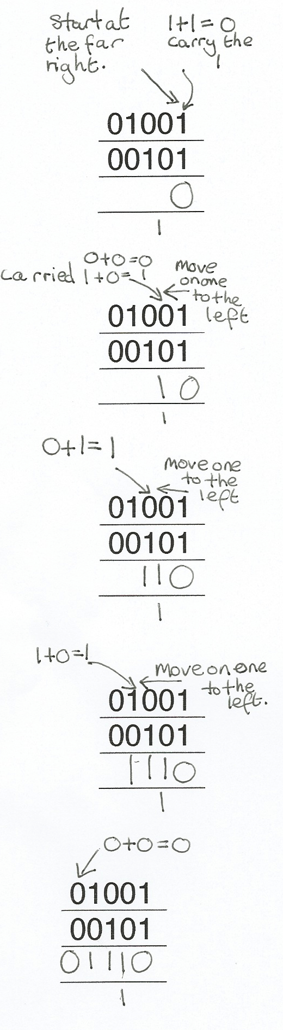
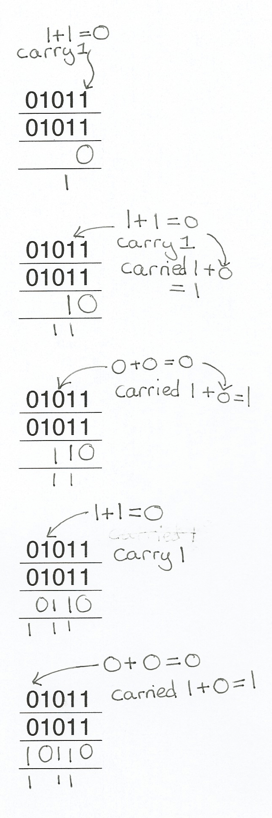

Example 2

Example 1

Worked examples
Binary addition
Remember the second column represents ones and the second column represents twos. You could write one and two above the columns. If you need to carry a one you can write it under the column or above the next column to the left.
00
00
01
00
01
01
Don’t forget to carry the 1
00
01
+

In the same way as addition with denary numbers you start binary addition at the column to the furthest right then add the next column to the left.
000
000
000
010
010
000
010
010
001
010

+

011
010
001
011
010
101
110
001
011
011

+

When you are adding more bits just work along from the right using the same method.
01101
00111
01101
01001
01011
01011

00111
10011
+

00101101
01001111
00101101
01001111
00101101
01001111

Find the spy using binary addition
Top secret information has been stolen from a government database and you have just received a coded message which contains the location of the spy. To decrypt the message add up the binary numbers below and convert the results into denary (base 10).
Then go onto the second page and find the letter for each number. This will spell out the location of the spy.

Remember 0+0 =0, 1+0 =1, 0+1=1, 1+1= (carried) 1 0
00010011
00000001

+

Converted into denary =

00000101
00100100

+

Converted into denary =

00010000
00010101

+

Converted into denary =

00011001
00011010

+

Converted into denary =

00011001
00010000

+

Converted into denary =

Use the table to decrypt the message by writing the letter that is above the denary number you found from the binary sums above. Write each letter in the boxes below to reveal to location of the spy.
The spy and the data are in

A | B | C | D | E | F | G | H | I | J | K | L
1 | 2 | 3 | 4 | 5 | 6 | 7 | 8 | 9 | 10 | 11 | 12
M | N | O | P | Q | R | S | T | U | V | W | X
13 | 14 | 15 | 16 | 17 | 18 | 19 | 20 | 21 | 22 | 23 | 24
Y | Z | a | b | c | d | e | f | g | h | i | J
25 | 26 | 27 | 28 | 29 | 30 | 31 | 31 | 33 | 34 | 35 | 36
k | l | m | n | o | p | q | r | s | t | u | v
37 | 38 | 39 | 40 | 41 | 42 | 43 | 44 | 45 | 46 | 46 | 48
w | x | y | z | ! | * | ( | ) | + | = | & | @
49 | 50 | 51 | 52 | 53 | 54 | 55 | 56 | 57 | 58 | 59 | 60
Overflow error
An overflow error occurs in a computer when the result of a calculation is bigger than the place meant to store it can handle. For example register or storage location can hold 8 bits but the result of a binary addition is 9 bits long not all the answer will fit in the location. In this case the answer will be wrong and an error occurs.
Complete the binary additions below, if the answer is more than a byte (8 bits) write in overflow error as the answer.
10110101
00011011
11011011
01111011

01011011
10010110
11011011
11011110

